Programming Fundamentals Lab Assignment #3

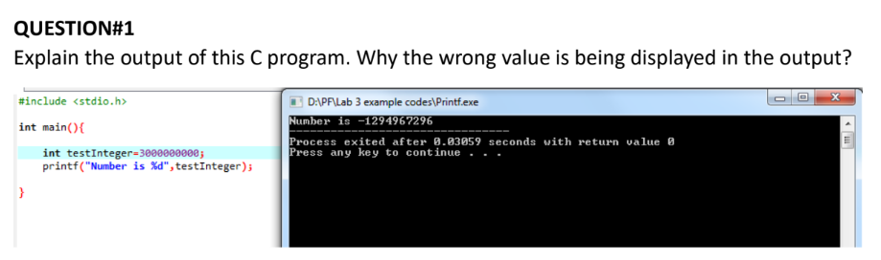

//ANS) int datatype has only 4 bytes memory so as a result of storing a larger number than that, it turns negative due to two's complement form.

Q2] Write a C program that takes two integer values as input from the user. Then swap the values taken from the user and display the output of the variables.

//ANS

#include <stdio.h>

int main() {

int a = 2;

int b = 1;

int temp;

printf("before swapping\n a = %d\n b = %d\n", a, b);

temp = a;

a = b;

b = temp;

printf("after swapping\n a = %d\n b = %d\n", a, b);

}

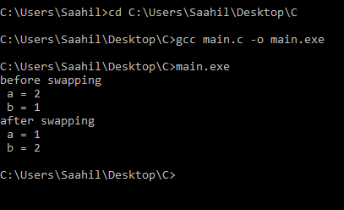

Q3] A customer asks the IT firm to develop a program in C language, which can take tax rate and salary from the user on runtime and then calculate the tax, the user has to pay and the salary he/she will have after paying the tax. This information is then provided to the user.

//ANS

#include <stdio.h>

int main() {

int taxRate, salary;

printf("enter tax rate in %: \n");

scanf("%d", &taxRate);

printf("enter salary: \n");

scanf("%d", &salary);

float tax = (taxRate \* salary)/100;

float salaryAfter = salary - tax;

printf("your tax is %.2f\n your salary is %.2f", tax, salaryAfter);

}

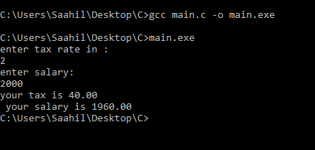

Q4] A car travelled back and forth from point A to point B. With a distance being (single trip) 1207KM. During the forward trip fuel price was 118/liter while returning it was 123/liter. Calculate the total fuel cost (both ways) and the fuel consumed (total trip). Use the car’s fuel average as input from the user (Input must be positive make some restrictions on only accepting positive input).

//ANS

#include <stdio.h>

int main() {

int avg;

int dist = 1207;

int fuelPriceBwd = 123;

int fuelPriceFwd = 118;

printf("enter your car's fuel average: \n");

scanf("%d", &avg);

float fuelNeeded = dist/avg;

float totalCost = fuelNeeded\*fuelPriceBwd + fuelNeeded\*fuelPriceFwd;

printf("you need %.1f of fuel\nyour cost is %.1f", fuelNeeded\*2, totalCost);

}

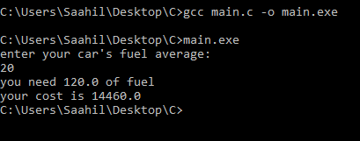

Q5] Construct a C program with the flowchart below. The input value of the principle must be between 100 Rs. To 1,000,000 Rs. The Rate of interest must be between 5% to 10% and Time Period must be between 1 to 10 years. Hint: these restrictions can be displayed in the form of message on the window.

//ANS

#include <stdio.h>

int main() {

long int p;

float r;

int t;

printf("enter principle between 100 and 1000000\n");

scanf("%li", &p);

while (!(p >= 100 && p <= 1000000)) {

printf("enter p again: \n");

scanf("%li", &p);

}

printf("enter rate between 5 and 10 percent: \n");

scanf("%f", &r);

while (!(r >= 5 && r <= 10)) {

printf("enter rate again: \n");

scanf("%f", &r);

}

printf("enter time between 1 and 10 in years: \n");

scanf("%d", &t);

while (!(t >= 1 && t <= 10)) {

printf("enter time again: \n");

scanf("%d", &t);

}

float interest = (p\*r\*t)/100;

printf("your interest is: %f", interest);

}

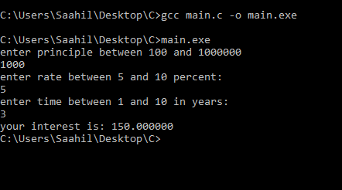

Q6] Construct a C program where you calculate the slope of two point (5,4), (3,2). Use format specifiers to cap the result to 3 decimal places.

//Q6

#include <stdio.h>

int main() {

int x1, y1, x2, y2;

printf("enter x coordinate of the first coordinate: \n");

scanf("%d", &x1);

printf("enter y coordinate of the first coordinate: \n");

scanf("%d", &y1);

printf("enter x coordinate of the second coordinate: \n");

scanf("%d", &x2);

printf("enter the y coordinate of the second coordinate: \n");

scanf("%d", &y2);

float gradient = (y2-y1)/(x2-x1);

printf("the gradient is %.3f", gradient);

}

